**Team ID :** PNT2022MID22921

### Project Title : Signs with Smart Connectivity for Better Road Safety

**Node-Red Creation**

https://node-red-wbonr-2022-11-10.eu-gb.mybluemix.net/red/#flow/5bf07f9675155547

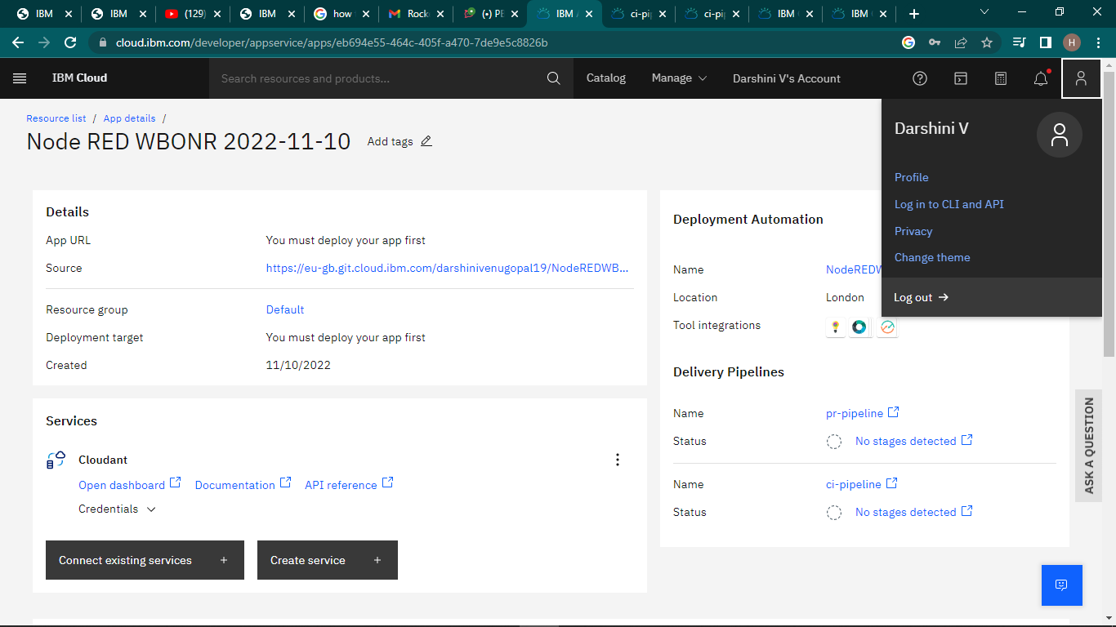

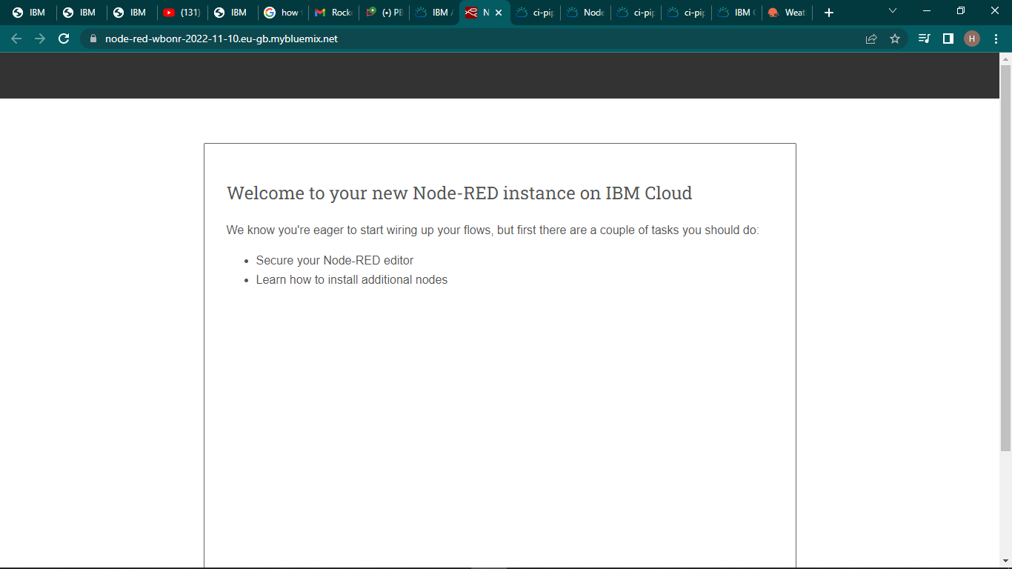

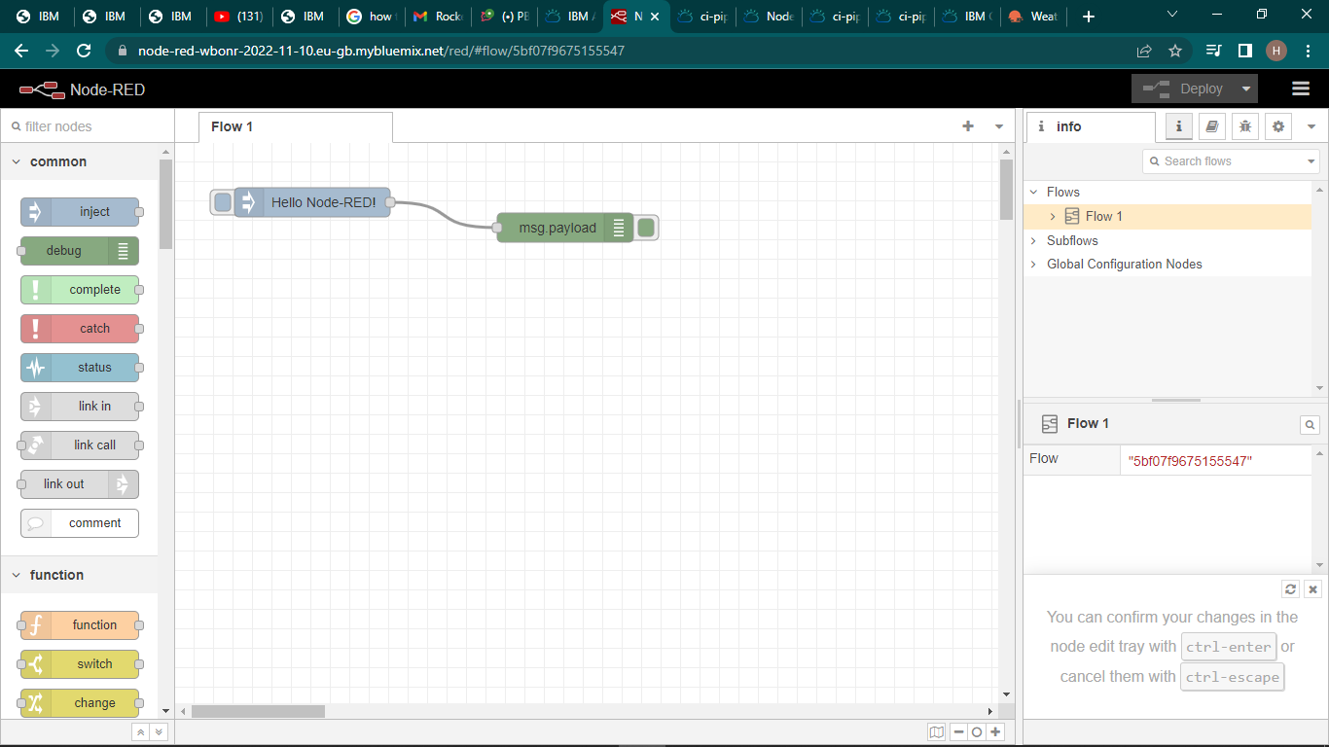

<https://cloud.ibm.com/developer/appservice/apps/eb694e55-464c-405f-a470-7de9e5c8826b>

